**Overview of the dSolar Model**

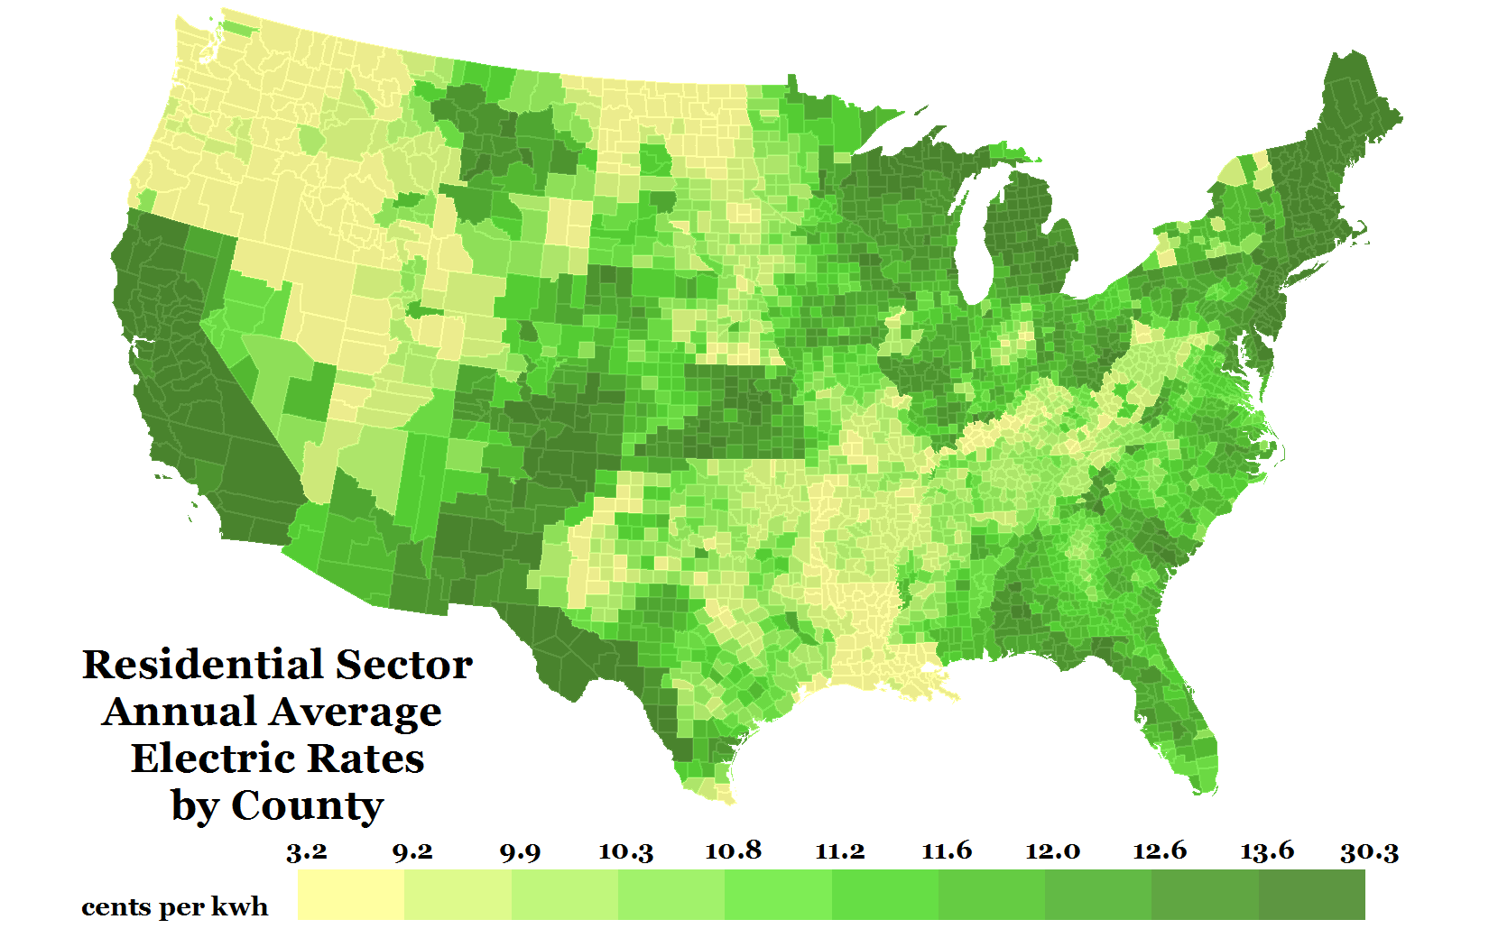

Figure 1: Adoption is modeled using an agent-based approach for each of the 3,108 counties in the continental U.S.

The Distributed Solar Demand (dSolar) model is a geospatially rich, bottom-up, market-penetration model that forecasts adoption of distributed energy resources (solar, storage, wind) for residential, commercial, and industrial entities in the continental United States through 2050. The model is an upgrade of the SolarDS model (Denholm et al. 2009) that provides a technology-neutral modeling platform, improves underlying algorithms and data, and includes several other feature enhancements. A key feature of the model is its high level of spatial resolution—adoption is modeled natively at the county level for representative households/businesses, with many datasets resolved to sub-county resolution.

Technology demand is modeled through an agent-based approach that includes four steps: i) identifying agents (i.e. potential customers) and their attributes using a probabilistic representation of the underlying datasets; ii) establishing measures of technical potential including resource quality, building, and load constraints for each of those agents; iii) conducting economic calculations using cash flow analysis that incorporates project costs, prevailing retail rates, incentives, and net metering considerations; and iv) technology adoption based on Bass-style adoption and other considerations of consumer behavior.

The dSolar model draws upon a large number of spatially-resolved datasets to improve forecasting precision. These include, but are not limited to: Ventyx Velocity Suite and EIA Residential/Commercial Building Energy Consumption Surveys to constrain end-user energy consumption patterns, OpenEI Utility Rate Database to calculate electric/gas bill savings, gridded land cover/land use (National Land Cover Dataset) and daytime/nighttime population (LandScan) datasetsto inform eligible sites for adoption, the National Solar Radiation Data Base, to inform resource quality, and LiDAR-derived building roof planes, for building-specific generation estimates.

The dSolar model is highly customizable, allowing for detailed and flexible scenario analysis. Scenario inputs available include market changes (e.g., capital costs, incentives, DER valuation, etc.), consumer behavior (e.g., adoption uptake, technology preference), and technical performance (e.g., performance improvements, siting criteria, and interaction with the distribution network). These inputs provide the ability to identify the critical market factors that drive end-use demand. As a result, dSolar is a powerful tool for exploring pathways for distributed energy resource deployment. Finally, results can be highly resolved spatially, to enable a multitude of distribution system planning applications.